***Trinity United Methodist Church***

October 13th, 2024 10:30 a.m. DIGITAL BULLETIN

Rev. David S. Vallelunga, Pastor; Selma Lippincott, Liturgist;

Caroline Fairchild, Violin; Christina Wong, Zoomologist

**COWBOY SUNDAY!**

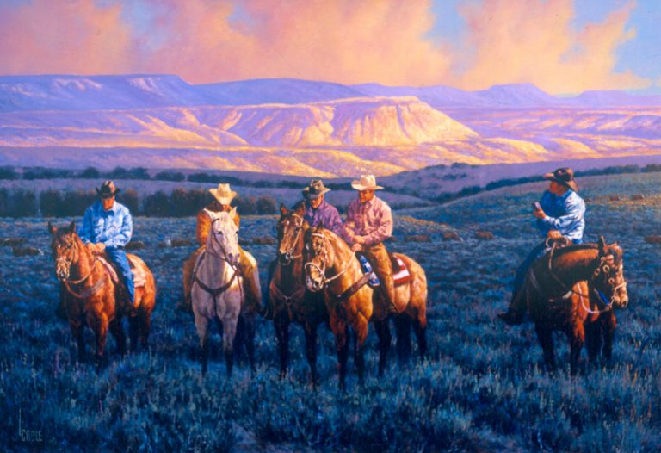

PRELUDE *Oh, What A Beautiful Morning*

WELCOME and ANNOUNCEMENTS Pastor Dave

WE GREET ONE ANOTHER IN CHRISTIAN LOVE

CALL TO WORSHIP Liturgist

In the Sermon on the Mount, Jesus reminds us:

**ASK, AND IT SHALL BE GIVEN YOU; SEEK, AND YOU SHALL FIND; KNOCK, AND IT SHALL BE OPENED TO YOU.**

Today we meet a true outsider who takes Jesus at his word,

**HE ASKS AND RECEIVES; HE SEEKS AND FINDS; HE KNOCKS, AND THE DOOR OF HEAVEN IS OPENED!**

May we be blessed along our own wilderness roads today,

**BLESSED WITH THE COURAGE AND CONFIDENCE TO ASK, AND SEEK, AND FIND! AMEN!**

HYMN “It’s Not an Easy Road”

**It’s not an easy road we are travelling to heaven,**

**for many are the thorns on the way.**

**It’s not an easy road, but the Savior is with us,**

**His presence gives us joy every day.**

**Chorus: No, no, it’s not an easy road;**

**no, no, it’s not an easy road;**

**But Jesus walks beside us**

**and brightens the journey,**

**and lightens every heavy load.**

**It’s not an easy road; there are trials and troubles,**

**and many are the dangers we meet.**

**But Jesus guards and keeps,**

**so that nothing can harm us,**

**and smooths the rugged path for our feet. CHORUS**

**Though we are often footsore and weary from travel,**

**though we are often bowed down with care;**

**a better day is coming when home in the glory**

**we’ll rest in perfect peace over there…CHORUS**

A TIME FOR THE CHILD IN ALL OF US

OUR LORD’S PRAYER

THE SCRIPTURE BEGINS Acts 8, selected verses

WE GATHER OUR PRAYERS BEFORE SINGING

SONG # 549 “Where Charity and Love Prevail”

**Where charity and love prevail,**

**there God is ever found;**

**brought here together by Christ’s love,**

**by love are we thus bound.**

**With grateful joy and holy fear**

**God’s charity we learn;**

**let us with heart and mind and soul**

**now love God in return.**

***SILENT PRAYERS***

**Forgive we now each other’s faults**

**as we our faults confess;**

**and let us love each other well**

**in Christian holiness.**

**Let strife among us be unknown,**

**let all contention cease;**

**be God’s the glory that we seek,**

**be ours God’s holy peace.**

***PASTORAL PRAYER***

**Let us recall that in our midst**

**dwells God’s begotten Son;**

**as members of his body joined,**

**we are in Christ made one.**

**Love can exclude no race or creed,**

**if honored be God’s name;**

**our common life embraces all**

**whose Maker is the same.**

THE SCRIPTURE CONTINUES Acts 8, selected verses

MUSICAL INSPIRATION *South of the Border*

THE SCRIPTURE CONCLUDES Acts 8, selected verses

HOMILY “Three Strikes and You’re In!”

OFFERTORY *The Wayward Wind*

DOXOLOGY and BLESSING OF THE GIFTS

**Praise God, from whom all blessings flow;**

**praise God all creatures here below;**

**praise God above, ye heavenly host,**

**praise Father, Son, and Holy Ghost.**

*HYMN “The Eunuch Song” sung to *Red River Valley*

**Long ago, down in dusty old Gaza,**

**a Jewish believer did ride,**

**on a chariot with room for another,**

**but no others would sit by his side.**

**For this guy was a very strange stranger,**

**dark of skin and not really a man,**

**He was lonely and sad and excluded,**

**but the Lord had a wonderful plan!**

**He was reading the prophet Isaiah,**

**but confusion was clouding his mind,**

**then the Lord sent a preacher named Philip,**

**an explainer both learned and kind.**

**Come and sit by my side, said the eunuch,**

**and explain this as best as you can,**

**they would not let me into the Temple,**

**dark of skin, and not really a man.**

**(Musical Interlude)**

**But our Philip, he didn’t seem frightened,**

**and he shared all the truth that he knew,**

**“Friend, the wonderful news of salvation**

**is extended to all, even you!”**

**When they came to some deep running water,**

**just imagine poor Philip’s surprise,**

**when the eunuch asked, “What is preventing**

**us from stopping and getting baptized?**

**Philip’s answer, it changed all of hist’ry,**

**Heaven’s Gates, they were flung open wide,**

**‘cause God’s love, it rolls on like a river,**

**and that love to no one is denied!**

**As your chariot rolls ever forward,**

**till you get to the end of the ride,**

**just remember there’s nothing preventing**

**traveling on with the Lord by your side.**

BLESSING *Forth we go to this world of woe, the trail before us bends; motives pure, but never sure how anything will end…and yet, our hearts get fresh new starts, as we, uplifted, go; with spirits warm, we will transform this daunting world of woe! Amen!*

POSTLUDE *Ragtime Cowboy Joe*