“Trinity UMC exists to ENGAGE people in joyful relationships with God and with each other, that we will GROW in Christ-like compassion and SHARE the blessings of the Holy Spirit.”

March 2nd, 2025 10:30 a.m. DIGITAL BULLETIN

Rev. David S. Vallelunga, Pastor; Stephanie McMillan, Liturgist;
Chris Wenger, Guest Musician; Christina Wong, Zoomlogist

TRANSFIGURATION SUNDAY

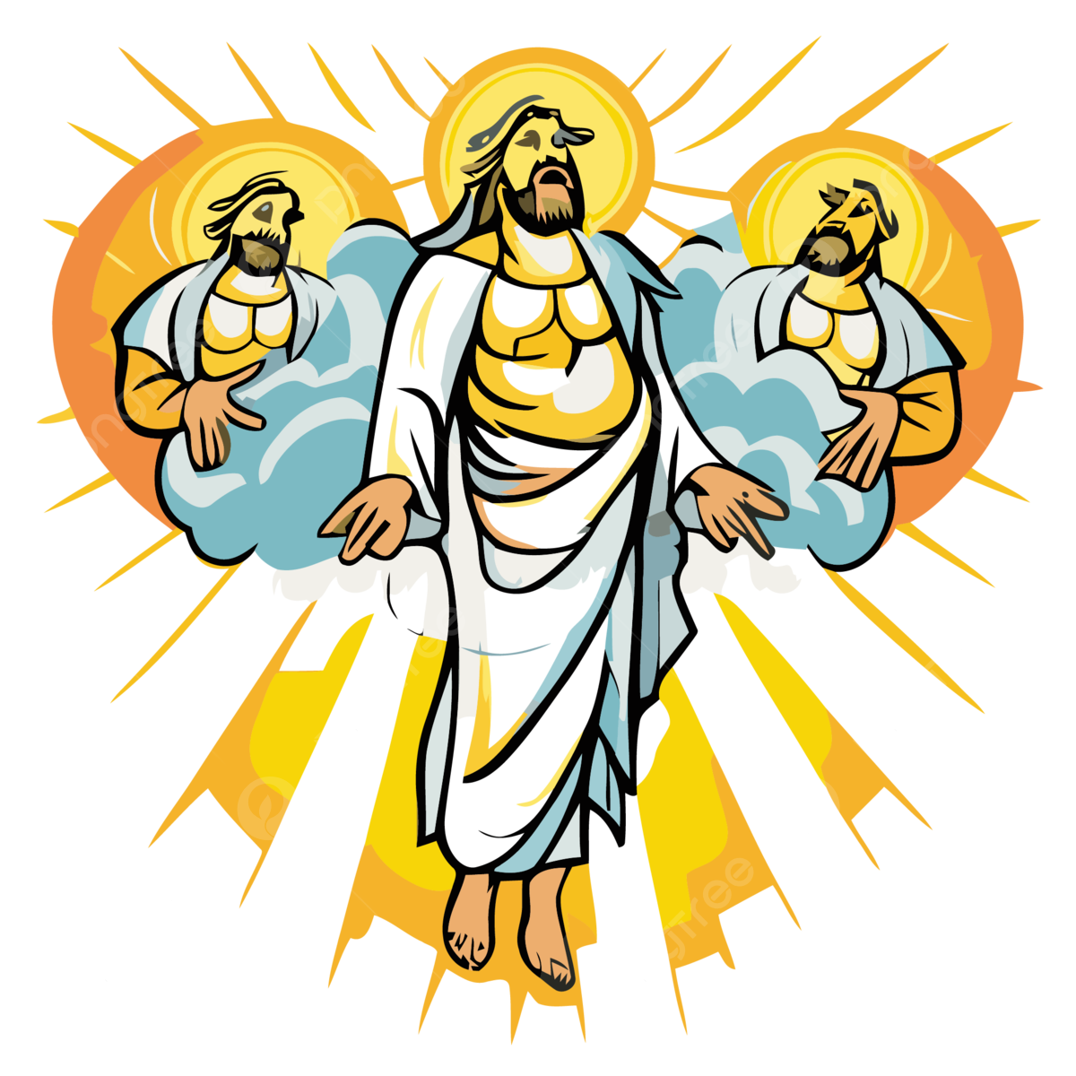
PRELUDE “It Had To Be You”
WELCOME and ANNOUNCEMENTS Pastor Dave
GREETING ONE ANOTHER IN CHRISTIAN LOVE

CALL TO WORSHIP Liturgist
Jesus took with him Peter and John
and James,
AND WENT UP ON THE MOUNTAIN TO PRAY.
And while he was praying, the appearance
of his face changed,
AND HE WAS TRANSFIGURED BEFORE THEM, AND HIS CLOTHES BECAME DAZZLING WHITE.
Suddenly they saw two men, Moses
and Elijah, talking to him.
THEY APPEARED IN GLORY AND WERE SPEAKING OF HIS DEPARTURE, WHICH HE WAS ABOUT TO ACCOMPLISH AT JERUSALEM.
Our Lord revealed his fullest self,
his full divine essence,
AND STILL REVEALS HIMSELF IN FULLNESS TO THOSE OF US WHO SEEK! AMEN!

*HYMN # 260 “Christ, Upon the Mountain Peak” sung to GROSSER GOTT

Christ upon the mountain peak,
stands alone in glory blazing.
Let us, if we dare to speak,
join the saints and angels praising:
share the joy of Jesus’ way,
this Transfiguration Day!

Trembling at his feet we saw
Moses and Elijah speaking.
All the Prophets and the Law
shout through them their joyful greeting:
follow Jesus, he’s the Way,
this Transfiguration Day!

Swift the cloud of glory came,
God, proclaiming in its thunder,
Jesus as the Son by name!
Nations, cry aloud in wonder:
share the joy of Jesus’ way,
this Transfiguration Day!

Jesus is the chosen One,
living hope of every nation,
hear and heed him, everyone;
sing, with earth and all creation,
follow Jesus, he’s the Way,
this Transfiguration Day!

A TIME FOR THE CHILD IN ALL OF US Pastor Dave
OUR LORD’S PRAYER

GOSPEL Luke 9:28-36 Liturgist
HOMILY “La Bella Figura” Pastor Dave

OFFERTORY “I Am the Light of the World”
DOXOLOGY and PRAYER OF CONSECRATION
Praise God from whom all blessings flow,
praise God all creatures here below,
praise God above, ye heavenly host;
praise Father, Son, and Holy Ghost!

THE GREAT THANKSGIVING IN SONG! Everyone

Alleluia, alleluia! To thy table, Lord,
we come, this holy day.

WE RECEIVE THE FEAST (We will come forward today for the bread and the juice…please kneel or stand when you receive. If you cannot come forward, please alert an usher, and the sacrament will be brought to you.)

CHRIS WENGER GUITAR MUSIC DURING COMMUNION

PRAYER OF GRATITUDE Pastor Dave

HYMN #258 “O Wondrous Sight! O Vision Fair!”

O wondrous sight! O vision fair
of glory that the church shall share,
which Christ upon the mountain shows,
where brighter than the sun he glows!
From age to age the tale declares
how with the three disciples there
where Moses and Elijah meet,
the Lord holds converse high and sweet.
The law and prophets there have place,
two chosen witnesses of grace;
the Father's voice from out the cloud
proclaims his only Son aloud.
With shining face and bright array,
Christ deigns to manifest that day
what glory shall be theirs above
who joy in God with perfect love.
And faithful hearts are raised on high
by this great vision's mystery;
for which in joyful strains we raise
the voice of prayer, the hymn of praise.

*BLESSING God’s voice has said to us, "This is my Son, my Chosen; listen to him!" If we have heard and believe, let’s not be like the disciples, silenced by fear. Let us share the good news that redeems the world! Amen!

*POSTLUDE “Cajun Two-Step”

