“Trinity UMC exists to ENGAGE people in joyful relationships with God and with each other, that we will GROW in Christ-like compassion and SHARE the blessings of the Holy Spirit.”

March 9th, 2025 10:30 a.m. DIGITAL BULLETIN

Rev. David S. Vallelunga, Pastor; Kathy Eckart, Organist;
Mary Wahl, Liturgist; Christina Wong, Zoomologist

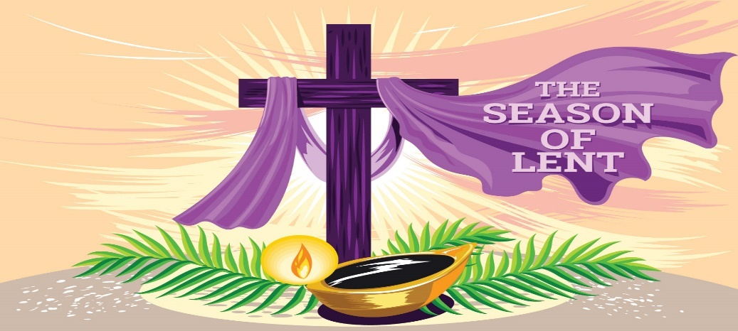

PRELUDE
WELCOME and ANNOUNCEMENTS Pastor Dave
GREETING ONE ANOTHER IN CHRISTIAN LOVE
LENTEN CALL TO WORSHIP
(sung together to the tune REDHEAD)

Now the cycle comes again,
time in thoughtful silence spend,
we would keep a holy Lent,
finding courage to repent;
as we gather now to pray
on this sacred Lenten day.

(The music will continue for a brief
time of prayer and confession)

Holy people, hear Good News,
as your hearts are now renewed;
we are gathered here as one,
Life Eternal has begun!
Follow Jesus in the Way,
on this sacred Lenten Day.
HYMN # 526 “What a Friend We Have in Jesus”

What a friend we have in Jesus,
all our sins and griefs to bear!
What a privilege to carry
everything to God in prayer!
O what peace we often forfeit,
O what needless pain we bear,
all because we do not carry
everything to God in prayer!

Have we trials and temptations?
Is there trouble anywhere?
We should never be discouraged;
take it to the Lord in prayer!
Can we find a friend so faithful
who will all our sorrows share?
Jesus knows our every weakness;
take it to the Lord in prayer!

Are we weak and heavy laden,
cumbered with a load of care?
Precious Savior, still our refuge,
take it to the Lord in prayer!
Do your friends despise, forsake you?
Take it to the Lord in prayer!
In his arms He'll take and shield you;
you will find a solace there.

A TIME FOR THE CHILD IN ALL OF US Pastor Dave
OUR LORD’S PRAYER

WE GATHER OUR PRAYERS BEFORE SINGING

PRAYER SONG # 534 “Be Still, My Soul”

Be still, my soul: the Lord is on your side.
Bear patiently the cross of grief or pain;
leave to your God to order and provide;
in every change God faithful will remain.
Be still, my soul: your best, your heavenly friend
through thorny ways leads to a joyful end.

A Time for Contemplation and Silent Prayers

Be still, my soul: your God will undertake
to guide the future, as in ages past.
Your hope, your confidence let nothing shake;
all now mysterious shall be bright at last.
Be still, my soul: the waves and winds still know
the Christ who ruled them while he dwelt below.
Pastoral Prayer

Be still, my soul: the hour is hastening on
when we shall be forever with the Lord,
when disappointment, grief, and fear are gone,
sorrow forgot, love’s purest joys restored.
Be still, my soul: when change and tears are past,
all safe and blessed we shall meet at last.

GOSPEL Luke 4:1-13 Liturgist
MUSICAL INSPIRATION
SERMON “Hunger Vs. Appetite” Pastor Dave

OFFERTORY DOXOLOGY and PRAYER OF CONSECRATION Liturgist

Praise God, from whom all blessings flow;
Praise God, all creatures here below;
Praise God above, ye heav'nly host;
Praise Father, Son, and Holy Ghost.

*HYMN #269 “Lord, Who Throughout These Forty Days”

Lord, who throughout these forty days
for us didst fast and pray,
teach us with thee to mourn our sins
and close by thee to stay.
As thou with Satan didst contend,
and didst the victory win,
O give us strength in thee to fight,
in thee to conquer sin.
As thou didst hunger bear, and thirst,
so teach us, gracious Lord,
to die to self, and chiefly live
by thy most holy word.
And through these days of penitence,
and through thy passiontide,
yea, evermore in life and death,
Jesus, with us abide.
Abide with us, that so, this life
of suffering over past,
an Easter of unending joy we may attain at last.

*BLESSING Lord, we realize the shortness of our stay in this world, so let us strive with our tongue and our deeds to become people of mercy. Sway our hearts towards you so that our limbs may follow. Prevent us from distractions that will harm our mind, body and soul; lead us not into temptations. Let this transient life be an opportunity to grow spiritually, and bring us out of ignorance into Light. Amen.

*POSTLUDE


